Network troubleshooting workflow
Check local IP address

- Check the local network connection
Open the CMD, type “ipconfig” enter
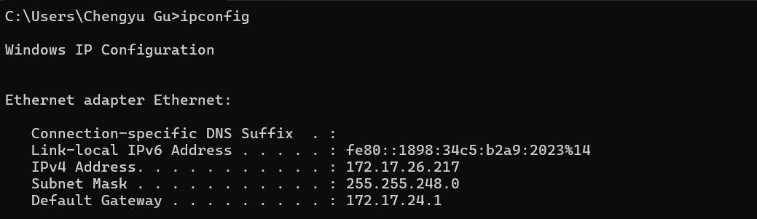
Noo
Yes
Check the cable
ipconfig
- Ping to the gateway
XF: 172.17.24.1
Yes
Yes
PVC: 172.17.32.1
Profile：172.17.48.1
Check IP settings
IP address defaults to DHCP
Noo
Ping to gateway

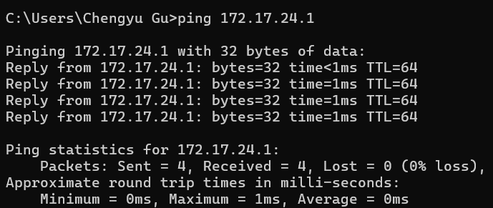
Yes
Noo
Ping to AS400
Yes
Finish check
Check DNS settings
Yes

- Ping the AS400 server from NJ
AS400: fpctx.fpcusa.com
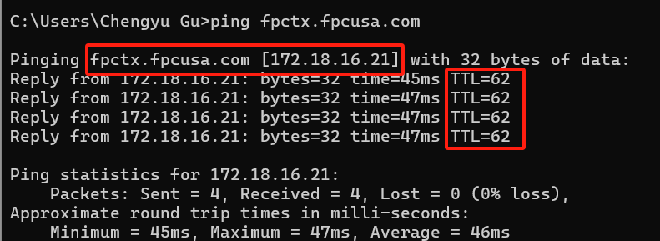

- Check the DNS address
172.17.8.25
172.19.254.52

- Ping the google.com

- Finish Check of the connection

XF:
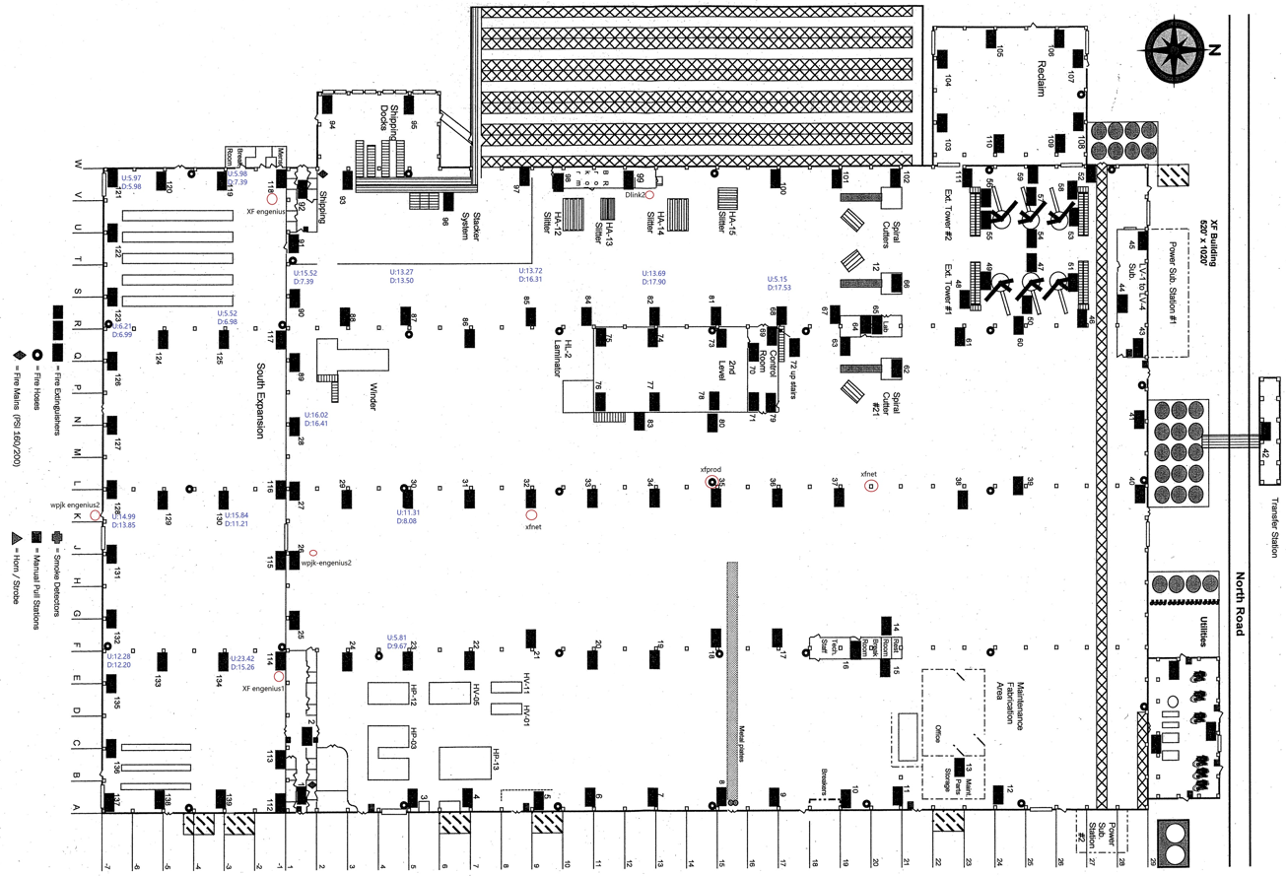

PVC:
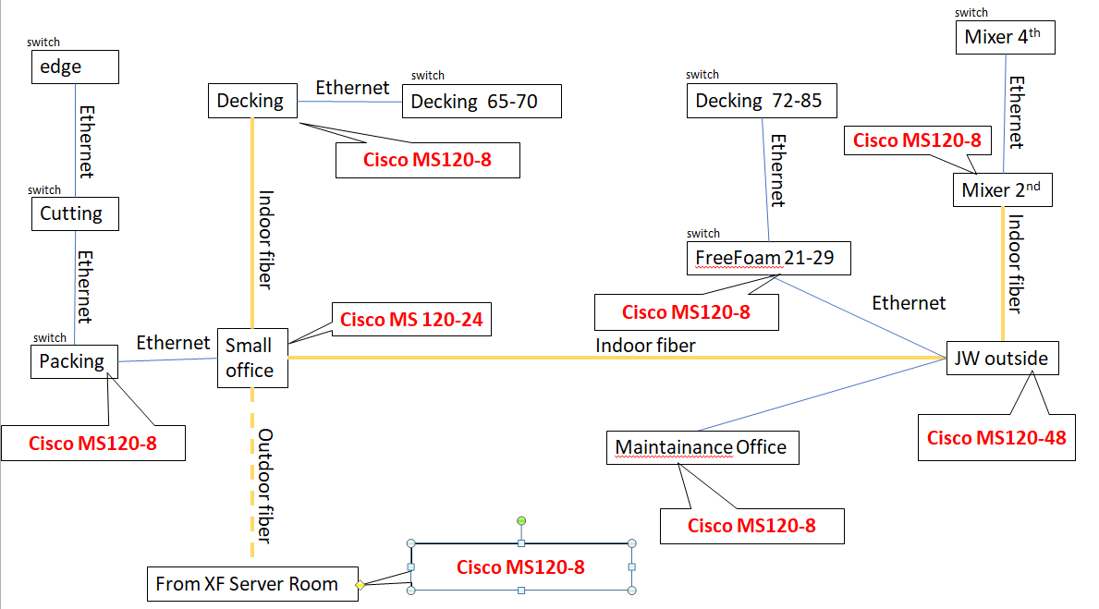
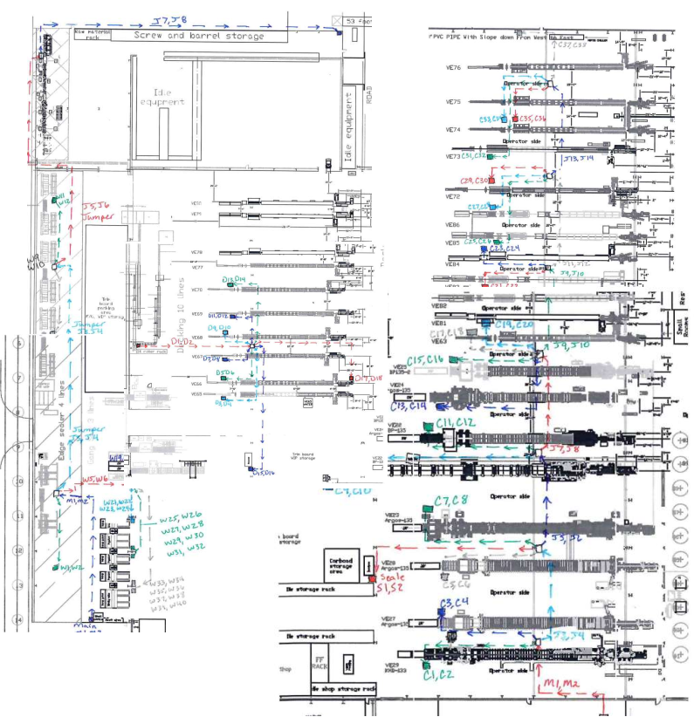
Profile:
